NORTHWIND INTERACTIVE
SALES DASHBOARD REPORT

Project Report Submitted By
Name: Kaviya D

Introduction
This project presents an interactive Northwind Sales Dashboard developed in Microsoft Power BI. The dashboard converts sales and order records into visual summaries that can be explored through year, category and region filters, together with detailed views for products, customers, months and employees.
The dashboard is designed to make the Northwind sales dataset easier to understand at a glance. Instead of relying only on raw records, it combines KPI cards, a monthly line chart, category columns, an employee bar chart, a customer-by-country chart and a detailed product table.

Objectives
- Analyze overall sales, orders, freight and quantity using Power BI.
- Create an interactive dashboard rather than a static report.
- Compare category-level sales information using the interactive category tooltip.
- Track the movement of total orders across months.
- Compare order contribution across employees.
- Examine the distribution of customers across countries.
- Provide detailed product-level information for further analysis.

Dataset Description
The dashboard uses Northwind sales records summarized by product, category, customer country, employee and month. The visible report includes ProductName, Category Name, Total Sales and Total Quantity Sold, together with dashboard measures such as Total Orders, Total Freight, Average Freight and Number of Customers.
Field / Dimension | Meaning | Use in Dashboard
ProductName | Product name | Product-level table and detailed analysis
Category Name | Product category | Category sales and unit-price comparison
Total Sales | Sales value | Main KPI and sales visuals
Total Quantity Sold | Quantity sold | Main KPI and product comparison
Country | Customer country | Customer distribution analysis
Employee Name | Employee name | Order comparison by employee
Month | Month of order | Monthly order trend

Data Preparation
- The Northwind sales data was brought into Power BI Desktop and organized for dashboard analysis.
- Sales, quantity and freight-related fields were used as numerical values for aggregation.
- Category Name, Country, Employee Name, ProductName and Month were used as analytical dimensions.
- Year, Category Name and Region were placed as slicers so the dashboard can be filtered interactively.
- The report was arranged into summary and detailed analysis views for focused examination.

Measures and Calculations Used
The dashboard is built around aggregated measures that dynamically display the values shown in the KPI cards and visuals. The visible measures include Total Orders, Total Freight, Average Freight, Number of Customers and Total Quantity Sold. A Total Sales value is also displayed in the product and sales analysis views.
Measure | Purpose in the Dashboard
Total Orders | Shows the total number of orders represented by the current dashboard context.
Total Freight | Shows the overall freight value represented in the dashboard.
Average Freight | Shows the average freight value.
Number of Customers | Shows the number of customers represented in the report.
Total Quantity Sold | Shows the overall quantity sold.
Total Sales | Shows the overall sales value in the sales analysis.

Dashboard Overview
The Northwind dashboard brings the sales and order analysis together through KPI cards, monthly and category visuals, employee comparison, customer-country analysis and a detailed product table. The Year, Category Name and Region controls allow the displayed values to be filtered.

Main Dashboard Overview
The main Northwind Interactive Sales Dashboard provides a consolidated view of order and sales activity. The KPI cards display Total Orders of 809, Total Freight of 63.96K, Average Freight of 79.05, Number of Customers of 91 and Total Quantity Sold of 51K.
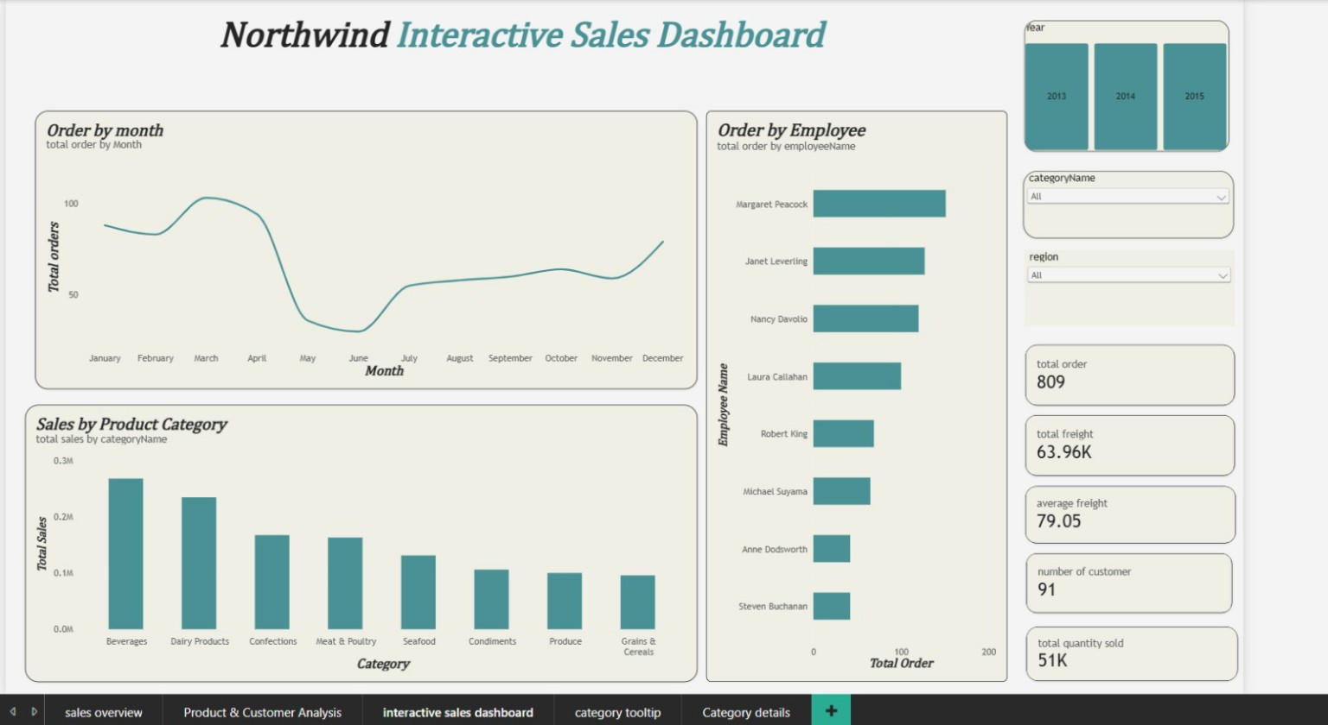

Key Observations
- The dashboard displays 809 total orders and 51K total quantity sold.
- Total Freight is shown as 63.96K, while Average Freight is 79.05.
- The dashboard displays 91 customers in the visible KPI section.
- The monthly chart shows changes in total orders across January to December.
- The category chart compares sales across eight product categories.
- The employee chart compares total orders for the employees visible in the dashboard.

Product & Customer Analysis
The Product & Customer Analysis view combines a detailed product table with a customer-by-country bar chart. The table displays ProductName, Category Name, Total Sales and Total Quantity Sold, allowing individual product records to be inspected alongside the customer distribution.
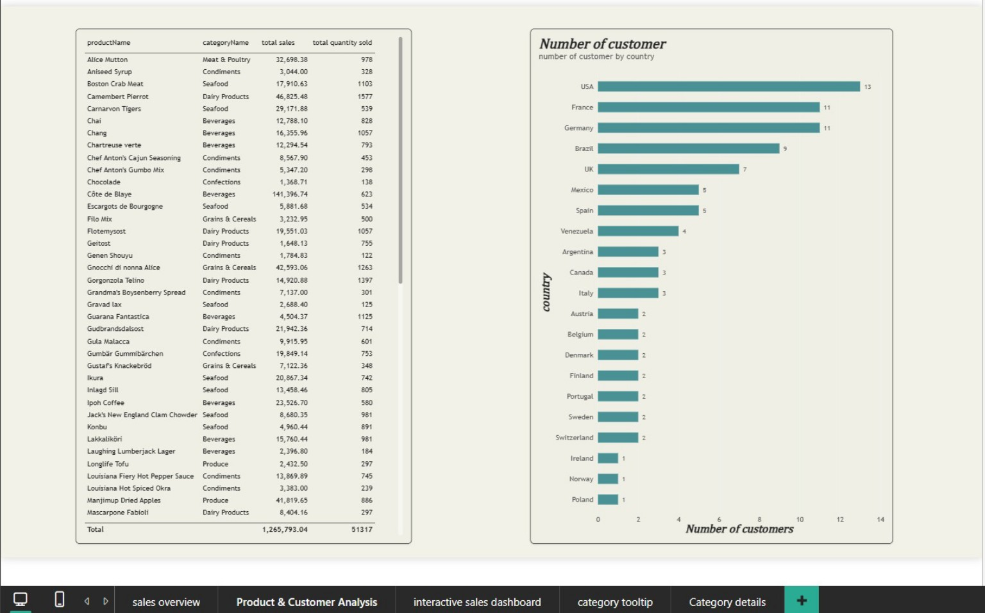

Key Findings
- The visible product table ends with Total Sales of 1,265,793.04 and Total Quantity Sold of 51,317.
- The table contains products from categories such as Beverages, Condiments, Dairy Products, Seafood, Confections, Produce, Grains & Cereals and Meat & Poultry.
- The customer-by-country chart shows the highest visible customer count for the USA at 13.
- France and Germany each show 11 customers, followed by Brazil with 9 and the UK with 7.
- The displayed country counts range from 1 to 13, showing differences in customer representation across countries.

Category Tooltip
The Category Tooltip page provides additional information when a category is selected or explored in the dashboard. It displays Total Sales, Total Sales by order Date and a category-level Sum of unit Price visual. This tooltip-style view supports quick comparison without leaving the main dashboard analysis.
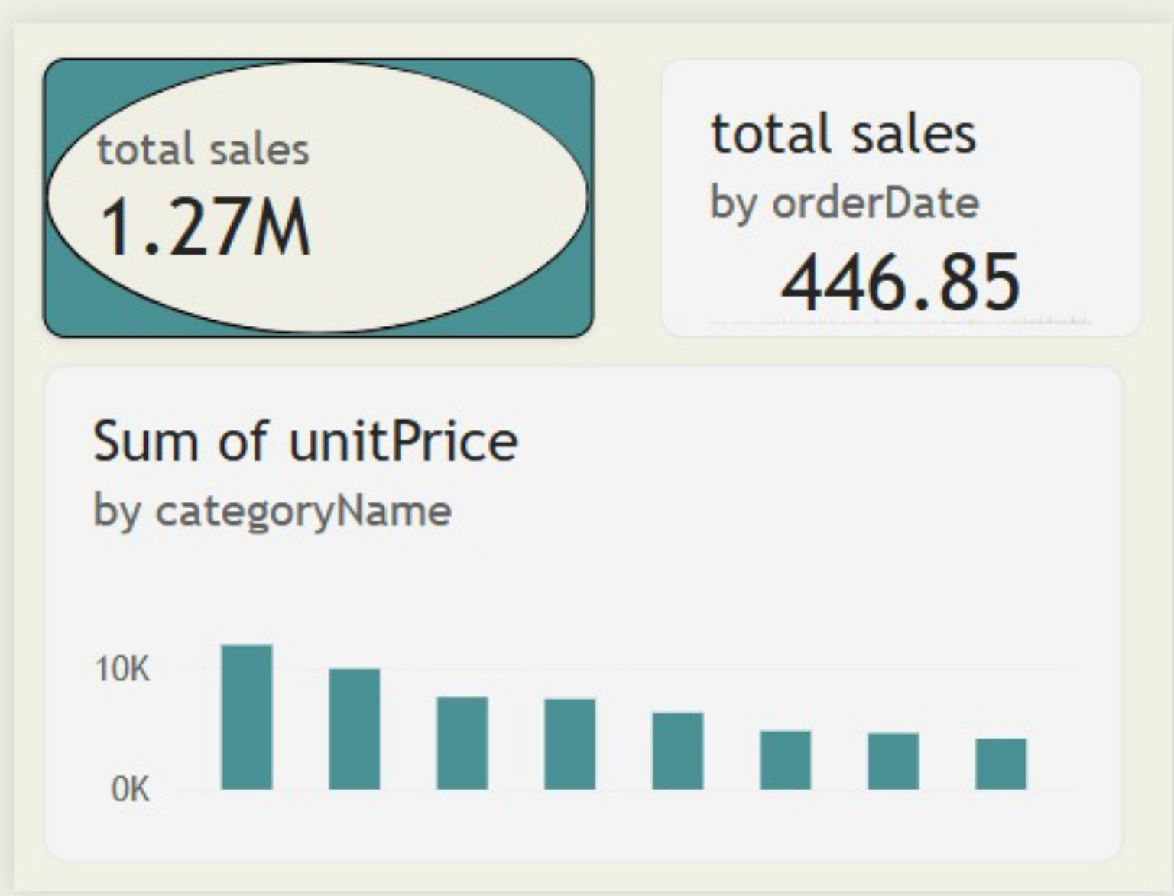

Key Findings
- The Category Tooltip displays an overall Total Sales value of 1.27M in the shown view.
- The Total Sales by order Date card displays 446.85 in the shown view.
- The category visual compares the Sum of unit Price across the displayed product categories.
- The chart uses the eight Northwind product-category groupings visible in the dashboard.
- The tooltip gives additional category-level information and helps the user understand the selected category without opening a separate detailed page.

Order by Month
The line chart presents total orders across the twelvemonth names used in the dashboard. It provides a visual way to compare order activity from one month to another and identify periods with comparatively higher or lower order counts.
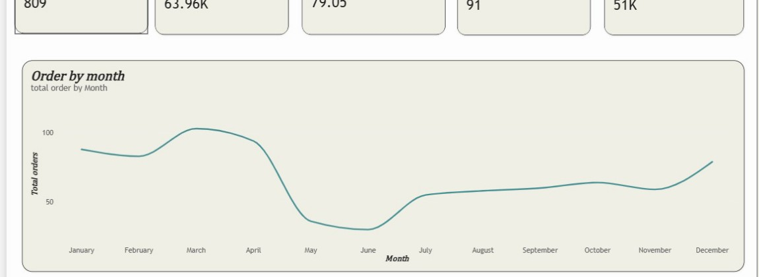

Key Findings
- March is the highest point in the displayed monthly sequence, at approximately 100 orders.
- January and April are also relatively high compared with the middle of the year.
- May and June form the lowest portion of the displayed sequence, at approximately 30–40 orders.
- Order activity rises again from July and remains relatively steady through the later months.
- December shows a noticeable increase compared with November.
The monthly visual can be used to identify changes in order activity and periods that may need closer investigation.

Order by Employee
The horizontal bar chart compares total orders across the employees visible in the dashboard. The horizontal layout makes employee names easier to read and allows the relative order contribution to be compared.
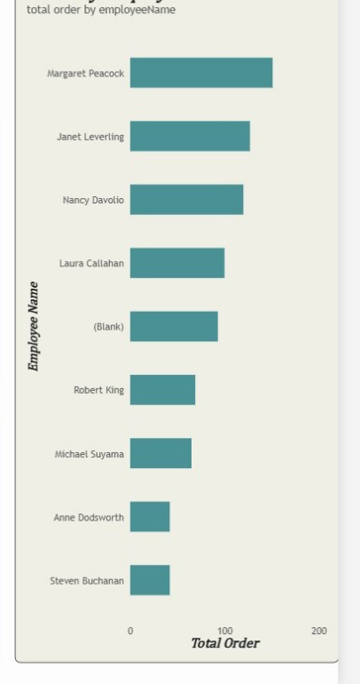

Key Findings
- Margaret Peacock has the longest visible bar and the highest displayed total order value.
- Janet Levering and Nancy Davolio follow among the higher visible employee totals.
- Laura Callahan and the (Blank) employee category appear in the middle of the displayed comparison.
- Robert King and Michael Suyama show lower totals than the leading employees.
- Anne Dodsworth and Steven Buchanan have the shortest visible bars in the displayed chart.
- The visual provides a direct comparison of employee-level order contribution.

Customer Distribution and Product Details
The customer-country visual shows how the 91 customers represented in the dashboard are distributed across the displayed countries. The product table complements this view by providing product-level sales and quantity information.
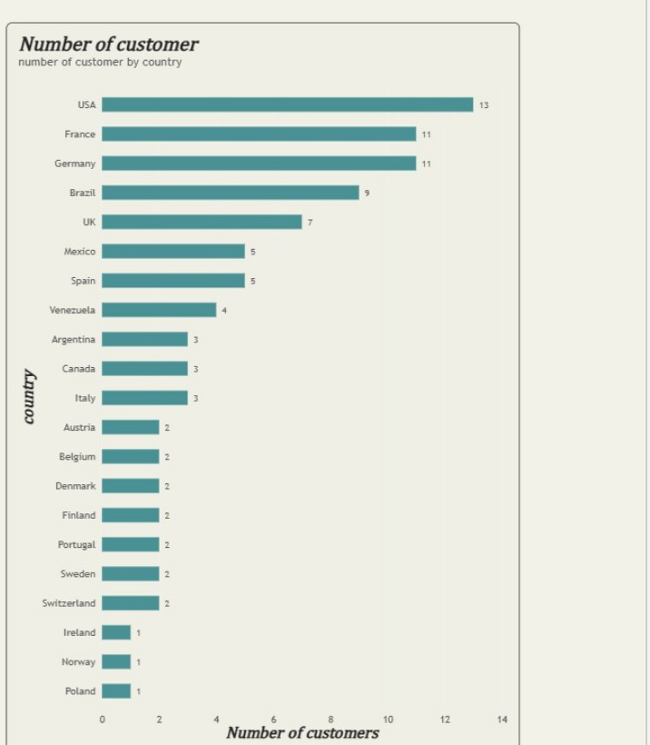

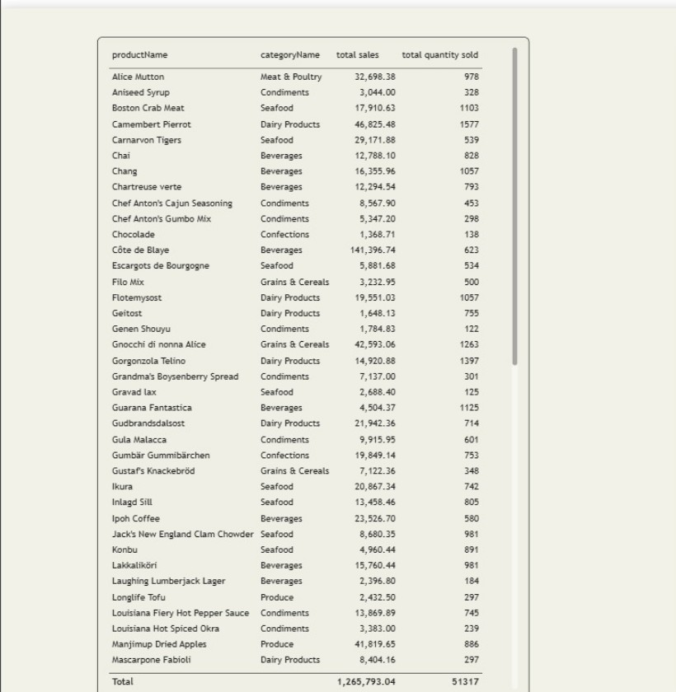

Key Findings
- The customer chart contains 21 visible countries, with the USA showing the highest displayed count of 13.
- The product table provides simultaneous comparison of product category, total sales and total quantity sold.
- The table's visible total is 1,265,793.04 in sales and 51,317 in quantity sold.
- The detailed views allow the summary dashboard values to be examined at a more granular level.

Key Findings
Area | Finding
Overall scale | The dashboard displays 809 total orders, 63.96K total freight, 79.05 average freight, 91 customers and 51K total quantity sold.
Sales analysis | The Product & Customer Analysis view shows Total Sales of 1,265,793.04 and Total Quantity Sold of 51,317.
Monthly orders | The monthly visual shows order variation across January to December, with the highest displayed point around March and lower values around May and June.
Category analysis | The dashboard compares eight product categories through sales and unit-price visuals.
Employee orders | The employee chart shows differences in total orders across the displayed employees.
Customer distribution | The customer-by-country chart shows the USA with 13 customers, followed by France and Germany with 11 each.
Product detail | The product table supports detailed comparison of product category, total sales and total quantity sold.
Interactivity | Year, Category Name and Region controls support filtering and interactive exploration of the dashboard.

Conclusion
The Northwind Interactive Sales Dashboard converts detailed sales and order records into an accessible Power BI report. The combination of KPI cards, monthly order tracking, category analysis, employee comparison, customer-country distribution and product-level details provides a clear view of the information presented in the dashboard.
The report also demonstrates how interactive visuals can support the examination of sales, orders, freight, customers and quantity sold from different perspectives. The combination of summary and detailed views makes the dashboard useful for exploring the underlying Northwind sales data.

